Vertical Order of a Binary Tree

Problem
Given a binary tree, we need to print the vertical order of the binary tree.

Example
Given a binary tree in array representation
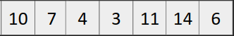

Its binary tree representation will be
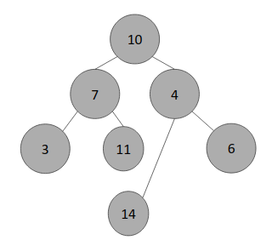

Computing horizontal distance approach
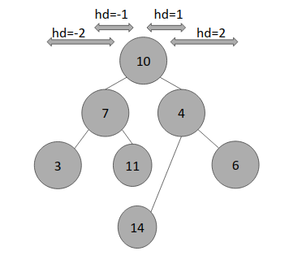

Vertical Order
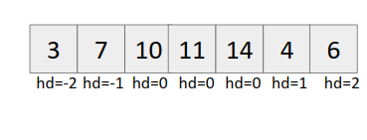
Approach (Using hashing)
- Create a map (say hd) whose keys store the distance from the node and value stores a vector of nodes at the respective horizontal distance.
- Start from the root node and recursively call left and right child with (hd-1) and (hd+1) as arguments.
Base Case:
if(current_node == NULL)
return;
- Push the value into the vector corresponding to the horizontal distance (hd).
- Output the map
Code
